Assignment 6.1

Taylor Anderson

7/14/2019

### a.

##### Explain why you chose to remove data points from your ‘clean’ dataset.

housing_clean <- na.omit(subset(housing, select =c(Sale.Price, square_feet_total_living, bedrooms, bath_full_count, bath_half_count, bath_3qtr_count, year_built, year_renovated)))

I removed many non deterministic values such as address and sale type. I have 8 variables remaining: price, squarefeet, year built, year renovated, bedrooms, and several bathroom variables.

### b.

##### Create two variables; one that will contain the variables Sale Price and Square Foot of Lot (same variables used from previous assignment on simple regression) and one that will contain Sale Price and several additional predictors of your choice. Explain the basis for your additional predictor selections.

sqfeet_lm <- lm(Sale.Price ~ square_feet_total_living, housing_clean)  
other_lm <- lm(Sale.Price ~ square_feet_total_living + year_built + bedrooms + bath_full_count, housing_clean)

I decided to add year built, bathrooms and bedrooms to the second model because they seem important to the price of a house. I am worried that bathrooms and bedrooms will have multicolinearity with square feet though.

### c.

##### Execute a summary() function on two variables defined in the previous step to compare the model results. What are the R2 and Adjusted R2 statistics? Explain what these results tell you about the overall model. Did the inclusion of the additional predictors help explain any large variations found in Sale Price?

summary(sqfeet_lm)

##   
## Call:  
## lm(formula = Sale.Price ~ square_feet_total_living, data = housing_clean)  
##   
## Residuals:  
## Min 1Q Median 3Q Max   
## -1800136 -120257 -41547 44028 3811745   
##   
## Coefficients:  
## Estimate Std. Error t value Pr(>|t|)   
## (Intercept) 1.891e+05 8.745e+03 21.62 <2e-16 ***  
## square_feet_total_living 1.857e+02 3.208e+00 57.88 <2e-16 ***  
## ---  
## Signif. codes: 0 '***' 0.001 '**' 0.01 '*' 0.05 '.' 0.1 ' ' 1  
##   
## Residual standard error: 360200 on 12863 degrees of freedom  
## Multiple R-squared: 0.2066, Adjusted R-squared: 0.2066   
## F-statistic: 3351 on 1 and 12863 DF, p-value: < 2.2e-16

summary(other_lm)

##   
## Call:  
## lm(formula = Sale.Price ~ square_feet_total_living + year_built +   
## bedrooms + bath_full_count, data = housing_clean)  
##   
## Residuals:  
## Min 1Q Median 3Q Max   
## -1719151 -120511 -42398 45744 3904824   
##   
## Coefficients:  
## Estimate Std. Error t value Pr(>|t|)   
## (Intercept) -4.430e+06 4.195e+05 -10.559 < 2e-16 ***  
## square_feet_total_living 1.744e+02 4.423e+00 39.424 < 2e-16 ***  
## year_built 2.340e+03 2.117e+02 11.053 < 2e-16 ***  
## bedrooms -1.375e+04 4.517e+03 -3.045 0.00234 **   
## bath_full_count 1.730e+04 6.095e+03 2.838 0.00454 **   
## ---  
## Signif. codes: 0 '***' 0.001 '**' 0.01 '*' 0.05 '.' 0.1 ' ' 1  
##   
## Residual standard error: 357300 on 12860 degrees of freedom  
## Multiple R-squared: 0.2194, Adjusted R-squared: 0.2192   
## F-statistic: 903.7 on 4 and 12860 DF, p-value: < 2.2e-16

With only square feet the model was able to account for 20.7% of the variability in the data. By adding the other two variables we increased to 22%.

### d.

##### Considering the parameters of the multiple regression model you have created. What are the standardized betas for each parameter and what do the values indicate?

library(lm.beta)  
lm.beta(other_lm)

##   
## Call:  
## lm(formula = Sale.Price ~ square_feet_total_living + year_built +   
## bedrooms + bath_full_count, data = housing_clean)  
##   
## Standardized Coefficients::  
## (Intercept) square_feet_total_living year_built   
## 0.00000000 0.42677620 0.09966661   
## bedrooms bath_full_count   
## -0.02979645 0.02783809

The values of standardized betas tells us that the number of square feet a house has the highest importance in determaining the cost. Year built is somewhat important and bedrooms and bathrooms are far behind that.

### e.

##### Calculate the confidence intervals for the parameters in your model and explain what the results indicate.

confint(other_lm)

## 2.5 % 97.5 %  
## (Intercept) -5252187.0182 -3607553.8714  
## square_feet_total_living 165.6868 183.0244  
## year_built 1925.4259 2755.5146  
## bedrooms -22607.0742 -4898.3341  
## bath_full_count 5351.3294 29243.8018

These confidence intervals show us that we are 95% certain that the true betas of each of these variables fall between these values. It is clear that there is multicollinearity with bedrooms unfortunetly.

### f.

##### Assess the improvement of the new model compared to your original model (simple regression model) by testing whether this change is significant by performing an analysis of variance.

anova(sqfeet_lm, other_lm)

## Analysis of Variance Table  
##   
## Model 1: Sale.Price ~ square_feet_total_living  
## Model 2: Sale.Price ~ square_feet_total_living + year_built + bedrooms +   
## bath_full_count  
## Res.Df RSS Df Sum of Sq F Pr(>F)   
## 1 12863 1.6689e+15   
## 2 12860 1.6420e+15 3 2.6831e+13 70.045 < 2.2e-16 ***  
## ---  
## Signif. codes: 0 '***' 0.001 '**' 0.01 '*' 0.05 '.' 0.1 ' ' 1

The anova table shows us that the multiple regression is significantly better than the simple regression model.

### g.

##### Perform casewise diagnostics to identify outliers and/or influential cases, storing each function’s output in a dataframe assigned to a unique variable name.

other_lm_diag <- subset(housing_clean, select = c(Sale.Price, square_feet_total_living, year_built, bedrooms, bath_full_count))  
other_lm_diag$residuals <- resid(other_lm)  
other_lm_diag$standardized.residuals <- rstandard(other_lm)  
other_lm_diag$studentized.residuals <- rstudent(other_lm)  
other_lm_diag$cooks.distance <- cooks.distance(other_lm)  
other_lm_diag$dfbeta <- dfbeta(other_lm)  
other_lm_diag$dffit <- dffits(other_lm)  
other_lm_diag$leverage <- hatvalues(other_lm)  
other_lm_diag$covariance.ratios <- covratio(other_lm)

### h.

##### Calculate the standardized residuals using the appropriate command, specifying those that are +-2, storing the results of large residuals in a variable you create.

other_lm_diag$large.residuals <- other_lm_diag$standardized.residuals > 2|other_lm_diag$standardized.residuals < -2

### i.

##### Use the appropriate function to show the sum of large residuals.

sum(other_lm_diag$large.residuals)

## [1] 329

### j.

##### Which specific variables have large residuals (only cases that evaluate as TRUE)?

head(other_lm_diag[other_lm_diag$large.residuals, c("Sale.Price", "square_feet_total_living", "year_built", "bedrooms", "bath_full_count", "standardized.residuals")])

## Sale.Price square_feet_total_living year_built bedrooms  
## 6 184667 4160 2005 4  
## 25 265000 4920 2007 4  
## 115 1390000 660 1955 0  
## 178 390000 5800 2008 5  
## 239 1588359 3360 2005 2  
## 246 1450000 900 1918 2  
## bath_full_count standardized.residuals  
## 6 2 -2.191642  
## 25 4 -2.448659  
## 115 1 3.114499  
## 178 4 -2.496458  
## 239 2 2.051065  
## 246 1 3.485119

Only showing the first 6 examples as the full data frame is 329 rows.

### k.

##### Investigate further by calculating the leverage, cooks distance, and covariance rations. Comment on all cases that are problematics.

high_res <- other_lm_diag[other_lm_diag$large.residuals, c("cooks.distance", "leverage", "covariance.ratios")]

sum(high_res$cooks.distance > 0.5)

## [1] 0

There are no cooks distances greater than 1, or even 0.5. This means that there are no points that would greatly alter results if removed.

average_leverage = (4 + 1)/12865  
sum(high_res$leverage > average_leverage * 2)

## [1] 98

sum(high_res$leverage > average_leverage * 3)

## [1] 65

There are 98 observations more than double the average leverage and 65 over triple the average leverage.

sum((high_res$covariance.ratios > 1 + (3*(4 + 1)/12865))|(high_res$covariance.ratios < 1 - (3*(4 + 1)/12865)))

## [1] 262

There are 262 observations outside of the standard range of covariance ratios.

### l.

##### Perform the necessary calculations to assess the assumption of independence and state if the condition is met or not.

library(car)

## Warning: package 'car' was built under R version 3.6.1

## Loading required package: carData

dwt(other_lm)

## lag Autocorrelation D-W Statistic p-value  
## 1 0.7210338 0.5579232 0  
## Alternative hypothesis: rho != 0

This model does have positive autocorrelation.

### m.

##### Perform the necessary calculations to assess the assumption of no multicollinearity and state if the condition is met or not.

vif(other_lm)

## square_feet_total_living year_built bedrooms   
## 1.930570 1.339428 1.577994   
## bath_full_count   
## 1.584923

1/vif(other_lm)

## square_feet_total_living year_built bedrooms   
## 0.5179818 0.7465875 0.6337161   
## bath_full_count   
## 0.6309454

There does not appear to be an issue with multicollinearity.

### m.

##### Visually check the assumptions related to the residuals using the plot() and hist() functions. Summarize what each graph is informing you of and if any anomalies are present.

plot(other_lm)

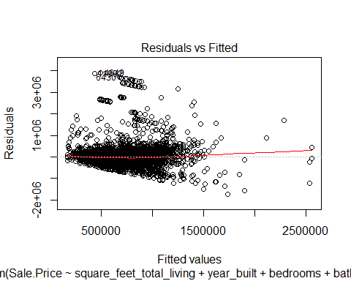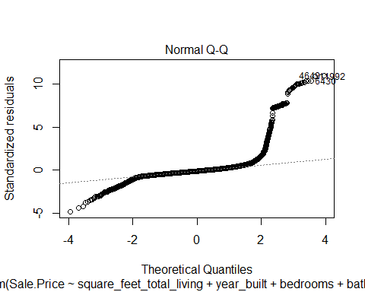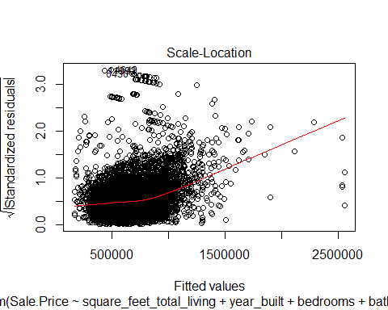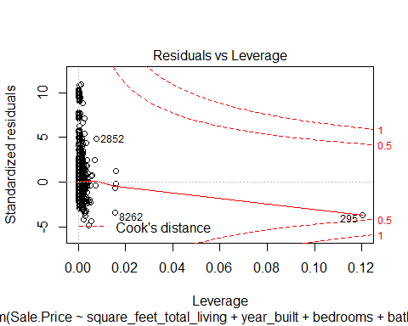 Residuals vs Fitted shows that the model may be heteroscedastic. Normal Q-Q shows that the data has heavy tails and has more values at extremes than we would expect with a normal distribution Scale-location shows that residuals are not spread evenly, especially in the more expensive homes. Residual vs leverage shows that there is no influencing case though case 295 is close.

library(ggplot2)

## Registered S3 methods overwritten by 'ggplot2':  
## method from   
## [.quosures rlang  
## c.quosures rlang  
## print.quosures rlang

histogram <- ggplot(other_lm_diag, aes(studentized.residuals)) + geom_histogram(aes(y = ..density..), color = "black", fill = "white", binwidth = .3) +  
 labs(x = "Studentized Residual", y = "Density")  
histogram + stat_function(fun=dnorm, args = list(mean = mean(other_lm_diag$studentized.residuals, na.rm = TRUE),   
 sd = sd(other_lm_diag$studentized.residuals, na.rm = TRUE)), color = "red", size = 1)

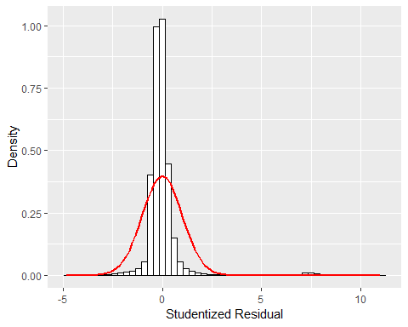

The residuals are not very normal. This histogram has some residuals further in the tail than we would expect and it is very narrow otherwise.

### o.

##### Overall, is this regression model unbiased? If an unbiased regression model, what does this tell us about the sample vs. the entire population model?

This model does seem to have bias and may not be a good model to use against another population.